Adaptive Wavelet Thresholding for Image Denoising Using Various Shrinkage under Different Noise Conditions

Abstract:
This paper presents a comparative analysis of different image denoising thresholding techniques using wavelet transforms. There are different combinations that have been applied to find the best method for denoising. Visual information transmitted in the form of digital images is becoming a major method of communication, but the image obtained after transmission is often corrupted with noise. . The search for efficient image denoising methods is still a valid challenge at the crossing of functional analysis and statistics.
Wavelet algorithms are useful tool for signal processing such as image compression and denoising. Image denoising involves the manipulation of the image data to produce a visually high quality image. The main aim is to modify the wavelet coefficients in the new basis, the noise can be removed from the data. In this paper, we analyzed several methods of noise removal from degraded images with Gaussian noise and Speckle noise by using adaptive wavelet threshold (Neigh Shrink, Sure Shrink, Bivariate Shrink and Block Shrink) and compare the results in term of PSNR and MSE.
1 Introduction:
An image is corrupted by noise in its acquisition and transmission. The goal of image denoising is to produce good quality of the original image from noisy image. Wavelet denoising techniques remove the noise present in the signal while preserving the signal characteristics, regardless of its frequency content. De-noising of natural images corrupted by noise using wavelet techniques is very effective because of its ability to capture the energy of a signal in few energy transform values.
Wavelet Thresholding is a technique that exploits the capabilities of wavelet transform for signal denoising. It removes noise by killing coefficients that are insignificant relative to some threshold, and turns out to be simple and effective, depends on the choice of thresholding parameter and the choice of this threshold determines, to a great extent the efficacy of denoising. Simple de-noising algorithms that use the wavelet transform consist of three steps. • Calculate the wavelet transform of the noisy signal. • Modify the noisy wavelet coefficients according to some rule. • Compute the inverse transform using the modified coefficients.
.2. Background:
The problem of Image de-noising can be summarized as follows, Let be the noise-free image and B the image corrupted with noise Z.
The problem is to estimate the desired signal as accurately as possible according to some criteria. In the wavelet domain, the problem can be formulated as
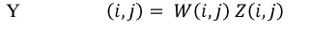
Where is noisy wavelet coefficient; W is true coefficient and noise. The performance of the image de-noising algorithms has been investigated in terms of two parameters PSNR (peak signal to noise ratio) and MSE (mean square error).
3. proposed system:
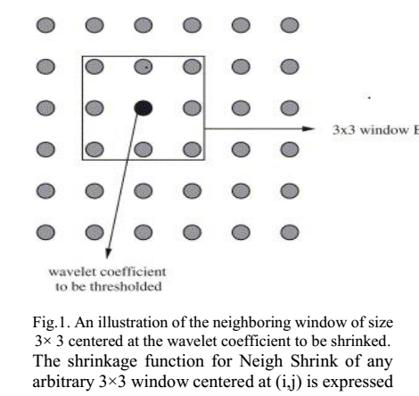
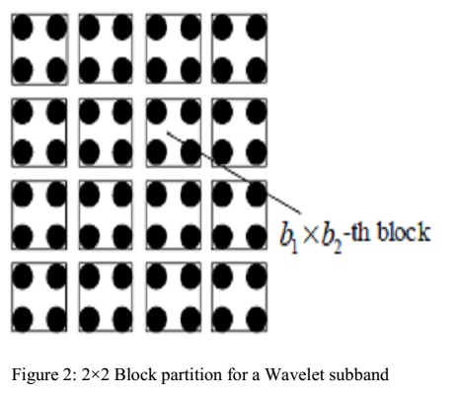
4. SOFTWARE AND HARDWARE REQUIREMENTS:
- Operating system : Windows XP/7.
- Coding Language : MATLAB
- Tool : MATLAB R 2012

SYSTEM REQUIREMENTS:
HARDWARE REQUIREMENTS:

- System : Pentium IV 2.4 GHz.
- Hard Disk : 40 GB.
- Floppy Drive : 1.44 Mb.
- Monitor : 15 VGA Colour.
- Mouse : Logitech.
- Ram : 512 Mb.

5. Conclusion:
This paper presents a comparative analysis of various image denoising techniques using wavelet transforms. The image formats that have been used in this work are JPG, BMP, TIF and PNG. We have experimented with four different thresholding methods (Sure shrink, Bivariate shrink, Neigh shrink, Block Shrink) using the various noisy images and report the results for the 512×512 standard test images Lena (Fig. 3). They are contaminated with Gaussian noise, salt and paper noise and speckle noise with standard deviations 10. Our results are measured by the PSNR and MSE..

References:
[1 ] Gao Zhing, Yu Xiaohai, “Theory and application of MATLAB Wavelet analysis tools”, National defense industry publisher, Beijing, pp.108-116, 2004.
[2] Aglika Gyaourova Undecimated wavelet transforms for image denoising, November 19, 2002.
[3] C Sidney Burrus, Ramesh A Gopinath, and Haitao Guo, “Introduction to wavelet and wavelet transforms”, Prentice Hall1997.S. Mallat, A Wavelet Tour of Signal Processing, Academic, New York, second edition, 1999.
[4] F.Abramovich and Y. Benjamini, “Adaptive thresholding of wavelet International Journal of Engineering Research & Technology (IJERT) Vol. 1 Issue 8, October - 2012 ISSN: 2278-0181 www.ijert.org 5 IJERT coefficients,”Comput. Statist. Data Anal., vol. 22, pp. 351 –361, 1996. [5] F. Abramovich, T. Sapatinas, and B. Silverman, “Wavelet thresholding via a Bayesian approach,” J. R. Stat. , vol. 60, pp. 725–749, 1998.
[6] Z. CAI, T. H. Cheng, C. Lu, and K. R. Subramanian, “Efficient waveletbased image denoising algorithm,” Electron. Lett. , vol. 37, no. 11, pp.683–685, May 2001.
[7] D. L. Donoho and I. M. Johnstone, ”Denoising by soft thresholding”,IEEE Trans. on Inform. Theory, Vol. 41, pp. 613-627, 1995.
[8] X.-P. Zhang and M. D. Desai, “Adaptive denoising based on SURE risk,” IEEE Signal Process. Lett., vol. 5, no. 10, pp. 265–267, Oct. 1998.
[9] Chang, S. G., Yu, B., and Vetterli, M. (2000). Adaptive wavelet thresholding for image denoising and compression. IEEE Trans. On Image Proc., 9, 1532–1546.

